Architecture of web
1. MVC- Model view Controller4
2. MVP – Model view Presetation
3. MVVM – model view view model

To create a website we need to create UI pages

port no is unique for every system which process the application

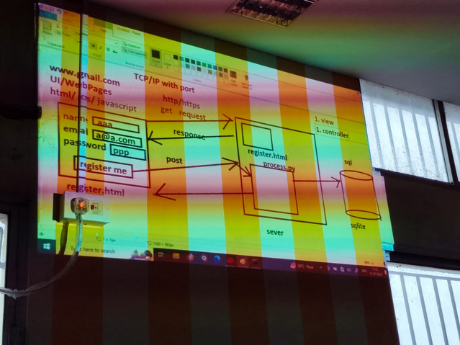
2 tier application

MVT

root
| - urls.py --> routing from browser
| - views.py --> controller of the class+++++es
|- models.py --> python classes to represent classes
| - templates
| - register.html --> all the html files

to map from models to db we use migration process

Workflow

pip3 –version
if not installed -> sudo apt install python3 python3-pip

sudo pip3 install virtualenv

mkdir and cd to there

virtualenv venv

python3 -m venv venv

source venv/bin/activate

pip install django

django-admin startproject proj1

cd proj1

django-admin startapp app

python manage.py runserver
to check

now add app to setting.py installed app = [ ... , ... ]

create a model in models.py (table)

python manage.py makemigrations
python manage.py migrate

now add urls and add pages in template

creating superuser

python manage.py createsuperuser

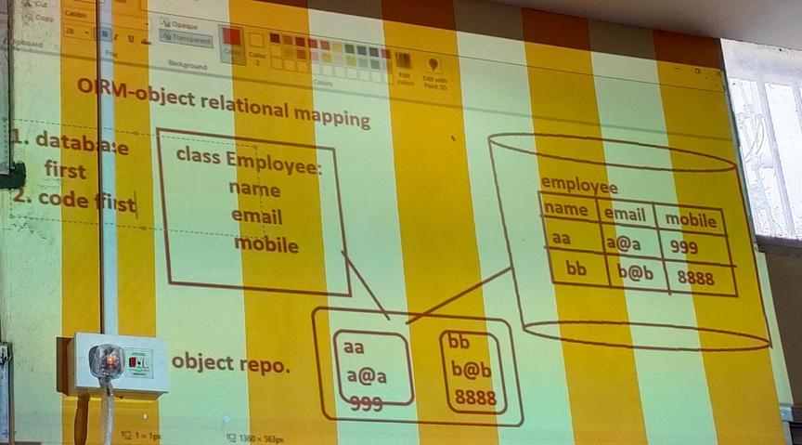
What is code-first approach – Django follow code first approach which means the code if first created then acc to code rows are generated

This is reverse engineering

bcz usually (other software like .net ) creates database first and acc to is code is generated to operate on it

